Week In Review: End of 2001
Alex Shvartsman
It has been an exciting couple of weeks, with several Grand Prix tournaments around the world played out as the last major events of the year 2001. Let's check out what happened at those tournaments.

Grand Prix-Las Vegas
One of the most anticipated North American Grand Prix tournaments (among the handful of gambling pros anyway), Grand Prix-Las Vegas has been years in the making. Some time ago the Wizards staff expressed concerns about holding a tournament in Vegas - they did not want Magic associated with gambling. Magic has matured and grown since, and a handful of outside observers drawing the wrong conclusions are no longer much of a threat, so Vegas finally got to host a Grand Prix.
Over 450 players attended this Extended Grand Prix - a very reasonable showing for a West Coast tournament (those tend to draw somewhat less of a crowd than East Coast Grand Prix). The metagame was heavily influenced by Pro Tour-New Orleans, with plenty of players running the winning Donate deck, and many others using Tomi Walamies's Call of the Herd control deck, which had been labeled "Operation Dumbo Drop" by some witty player. There were also plenty of Junk decks, several of which made it into the Top 8, taking advantage of a very control-oriented field. But it was Sol Malka's rogue creation - a green-black deck called "The Rock and its Millions" that took the gold.
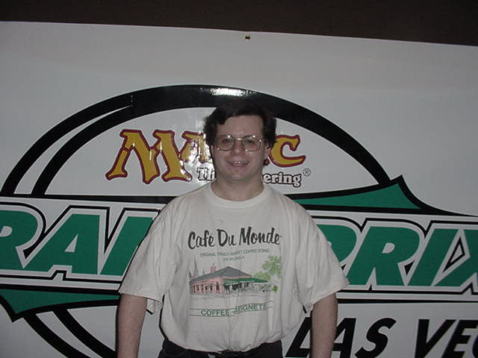
Malka is well known for designing and playing rogue decks. He tends to play creature utility, such as Living Death-based decks. 'The Rock' has been around for a couple of years now, with Malka navigating it across various Standard and Extended metagames. Mike Flores chose to play this deck in a Grand Prix trial a week before Las Vegas. He surprised his opponents, and probably himself, by not losing a game as he earned a three round bye. The byes did not help Flores make Day 2 of GP-Las Vegas, but he did use the deck to win a Pro Tour Qualifier on Sunday. Another New Yorker known for playing rogue decks - Mike Pustilnik - picked up The Rock and used it in Las Vegas, adding a Choke main deck. Although plenty of blue decks were played, none made the Top 8, and there were no Donate anywhere in the Top 16 - a surprise to be sure, since it was generally considered the best deck in the format.
Another notable Top 8 finisher was Rob Dougherty who, along with teammate Darwin Kastle, brought an innovative "Wild Zombies" strategy to the tournament. Bostonians generally did well in the tournament, with Joel Frank and Dave Humpherys both placing in Top 16. Humpherys might be the most consistently successful North American Grand Prix participant so far this season, closely followed by Brian Davis, who also posted another Top 16 finish.
Among other notable Top 32 finishers were Mexico's Gerardo Godinez (foreign players are a rare sight at U.S. GPs) and Stompy creator Bill Macey, coming out of retirement to a major tournament for the first time in years.

Grand Prix-Curitiba
Held during the same weekend as Grand Prix-Vegas, Curitiba still managed to attract several pros from outside of South America. Ryan Fuller, Antoine Ruel, Olivier Ruel, and I were the four visitors in the field of 300+ players from Brazil, Argentina, Uruguay and Chile.
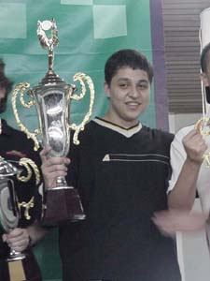
Much like in Vegas, Donate was among the most popular decks. Like in Vegas, it failed to earn any Top 8 finishes and, I am reasonably certain, there were no more than one Donate deck in Top 16. It was not a rout for the pros though - Fuller finished 23rd and Olivier Ruel dropped out during Day 2, once he no longer had a chance at finishing in the money. Antoine Ruel however, piloted his Walamies deck to a third place finish. He remained near the top of the standings for much of the tournament, falling to the eventual champion Guilherme Dei Svaldi.
I played the same Finkula deck designed by Craig Wescoe that I used at Pro Tour-New Orleans. I would have been satisfied with a Top 32 finish. However, I managed to keep up an excellent streak instead - my three Grand Prix results in Brazil are 4th, 2nd, and 2nd place. Perhaps one of these days I will win one!
This weekend however, it was Guilherme Dei Svaldi's turn to shine. He navigated his Five-Color Green variant packing plenty of rogue cards, managing to defeat many high-profile opponents on the way. An unorthodox deck build featured cards like Armageddon and Winter Orb - excellent utility spells that has been overlooked by many others lately.
Except for the very first Grand Prix-Rio, where Steve OMS and Jon Finkel met in the finals, Brazil has managed to keep the trophy at home every time. Unfortunately, it may be a while until the next time they have an opportunity to do so - there may not be another GP there for as long as a year.

Grand Prix-Sendai
This event took place a week after Grand Prix in Las Vegas and Curitiba - so Japanese players had plenty of time to adapt to the latest shifts in the metagame. Some (myself included) expected the turnout to rival that of Grand Prix-Kobe a few months ago, when over a thousand people showed up to play! And why not - Sendai is a large city only a two hour bullet-train ride from Tokyo, and this Grand Prix would qualify the players for Pro Tour close to home - PT-Osaka. However, we did not count on a blizzard that was forecast for the area. The snow kept many players who might otherwise have traveled to Sendai away - resulting in one of the smallest Japanese Grand Prix to date - at a mere 500+ people! Certainly no slouch by the international standards, it was indeed a low turnout for Japan.
Although the total number of players was below expectations, there were more international players than ever previously seen at a Japanese GP. Several players from Singapore (including the notorious Nick Wong) were joined by a large group of Americans, including Chris Benafel, Dan Clegg, Brian Hegstad. This was also the first international Grand Prix appearance by Worlds' finalist Alex Borteh. Mike Long and I were both there managing our dealer booths, both of us opting to play in the tournament anyway.
It was a disappointing performance from the North American pros. Benafel, Hegstad, Borteh and I all finished in Top 32. Others were out of the money, except Mike Long. Long has long been one of the most interesting personalities in the game, and one of most controversial. Fresh off yet another round of controversy caused by his disqualification at Grand Prix-Atlanta, Long recently conceded in the finals of an Osaka PTQ as he was not interested in attending the Pro Tour at the time. However, by GP-Sendai he was reinvigorated and ready to fight for an invite.
Mike came up with a very interesting variation on Alan Comer's u-g "Miracle Growth" deck. The biggest problem with Comer's deck is that its creatures are quite weak, making the deck a poor choice against other aggressive strategies such as Sligh or Three-Deuce. Long replaced the puny Merfolk with powerful green creatures such as Werebear and Wild Mongrel. A risky proposition in a deck that sports four green mana sources, this nevertheless paid off for the PT-Paris champion, as he navigated the deck all the way to the semifinals.
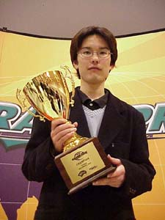
Other notable Top 8 finishers included Japanese wunderkind and the current Rookie of the Year Katsuhiro Mori as well as Itaru Ishida and Jin Okamoto - both well-known in their country. The top prize went to rookie Kazuaki Arahori, who was playing an extremely interesting u-b control deck similar in spirit (though not cards used) to Squirrel Prison. Arahori used Zombie Infestation and three Squees (which he would fetch with Intuition) to generate a horde of 2/2 zombies, and an Opposition/Winter Orb combo to lock up the opponent completely. At first glance the deck looks extremely strange, but it clearly worked in a very versatile field, where the most common decks appeared to be Donate and The Rock.

Magic Online

The much-anticipated software that will allow fans to play and draft online has entered its public beta stage. Wizards of the Coast senior marketing manager Kyle Murray expects as many as 30,000 beta testers to sample the program before its forecasted Spring 2002 release. Brainburst editor Scott Johns recently interviewed Mr. Murray. Read the interview at brainburst.com.

Fact or Fiction Restricted in Type 1
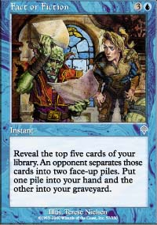
On December 1, Fact or Fiction has been added to the list of cards restricted in Type 1. It was also banned in Type 1.5. No changes were made in the Standard or Extended formats. The next Banned/Restricted update will be issued by the DCI on March 1st.

2002 Grand Prix Locations Announced

Grand Prix locations for 2002 were posted on the Wizards of the Coast web site last week. North American players can look forward to playing in Houston, Tampa, Milwaukee, New Jersey, Cleveland, Philadelphia and Los Angeles. European players will enjoy such Grand Prix locations as Lisbon, Heidelberg, Antwerp, Barcelona, Naples, London, Hamburg, Copenhagen, and Reims. Asian Grand Prix will include Fukuoka, Kuala Lumpur, and Nagoya.
The schedule is tentative and subject to change. More events may be added, especially later in the year. No events have been posted so far in South America, nor the events in Asia past May.

Magic Trivia
Last question:
What Magic card has appeared in most card sets?
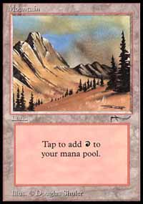
Mountain is the most commonly printed Magic card. It gets a drop on all the other basic lands because of Arabian Nights, where the infamous AN Mountain was printed (it looks just like a beta Mountain, but has the AN scimitar symbol). If you do not wish to count basic lands, Stone Rain is the most printed common card, thanks to its appearances in Portal sets and most standalone expansions.
New Question:
Courtesy of Andrew:
Can you name two Magic cards whose names are anagrams of each other? (That is, you can change one name to another by rearranging the letters.) There are at least two such anagram pairs.
Please do not email answers to me. The correct answer will be posted in the next column.

Quote of the Week
"I think I want to build a Battle of Wits deck" - Toby Wachter
"Isn't there some kind of pill you can take for that?" - Josh Bennett

Play of the Week
Most of you have heard about the New York - Boston Grudge Match. Set up by the owners of Neutral Ground and Your Move Games stores, this series of Standard tournaments has often been a beacon, setting the trends of the Standard metagame when most pros would look to other formats. Until this weekend.
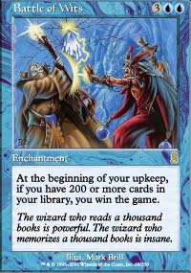
The tournament began reasonably enough. There were nearly 20 players in attendance, including some high profile players such as Mike Pustilnik. However, a few hours and eight rounds of play (including Top 8) later, no one would think of the Grudge Match the same way. Why, you ask? Because the winning deck included 247 cards.
That's right. A Battle of Wits deck won a Grudge Match. Navigated by Sideboard and NG writer Toby Wachter, he got helped along the way by a concession in round 2 from Sean McKeown (who is already qualified for the GM Top 32 playoff) and two intentional draws - but he won the other five rounds legitimately! Although this is a somewhat unusual selection for a Play of the Week, I do believe that casting Battle of Wits for the win in the finals of a Grudge Match definitely qualifies.
You can check out Toby's deck list and read his excellent article at neutralground.net.
Got an interesting news story, comment, quote, play of the week, or Magic trivia to report? Please e-mail me at ashv80@hotmail.com.

